

How to Place a Referral to the McLaren Bariatric Surgery Program

- Navigate to the order entry area. Search for “Referral – Ambulatory”
  - 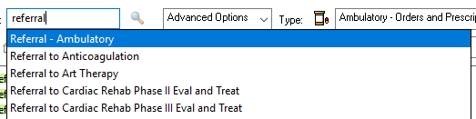

- Select the next button. Select “Bariatric” in the medical service box.
  - 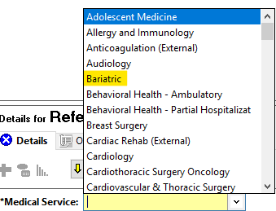

- In the “Refer to” box, click the binoculars button.
  - 

- Select the appropriate location.
  - 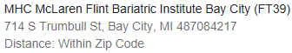
  - 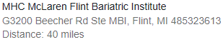
  - 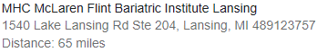

- Sign the order. The referral will now be in your clinic’s outgoing referral que for processing.

